September 05, 2019

Thank you for attending the Public Meeting for the potential Intersection Improvements at Medlock Bridge Road/E. Jones Bridge Road and SR 141/Peachtree Parkway. Our goal is two-fold: 1) to provide you with information on the potential alternatives for the project and 2) to provide an opportunity for you to give us your comments on each alternative. In this handout package, you will find the layout of each alternative, information and data for each option, and a comment card.

As you enter the room, please take a look at the project displays. There will be a formal presentation that will cover all of the alternatives included in this handout. Following the presentation, City representatives, wearing nametags, are available to discuss the project and answer your questions.

We hope you will take the opportunity to tell Peachtree Corners Public Works what you think. Listed below are several ways to comment on the project. Your comments are important to us and, should you provide comments by one of the methods noted below. All comments will become part of the project’s official record.

While you are attending the public meeting, you can provide your comments today by filling out the comment card provided with this handout and dropping it in the comment box.

You can also provide your comments by Monday, September 30, 2019 by emailing your comments to publicworks@peachtreecornersga.gov.

Again, thank you for attending this Public Meeting. If you should have any questions or need additional information, feel free to contact our office by telephone at 678-691-1200 or email at publicworks@peachtreecornersga.gov.

Sincerely,

City of Peachtree Corners
Department of Public Works

Concept Layout
SR 141 at East Jones Bridge Road/
Medlock Bridge Road
Alternative #1: No Build
September 2019

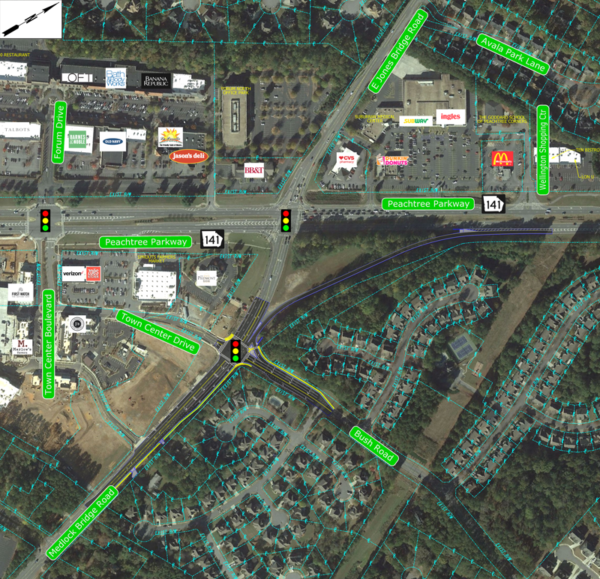

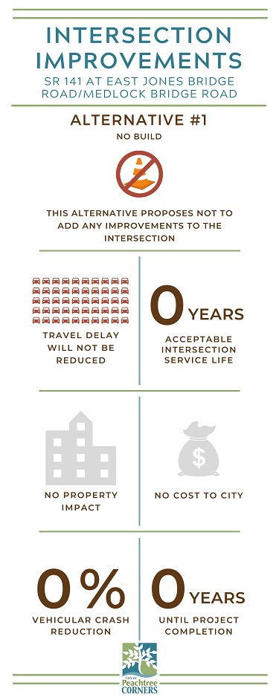
Concept Layout
SR 141 at East Jones Bridge Road/
Medlock Bridge Road
Alternative #2: Conventional Intersection Improvements
September 2019

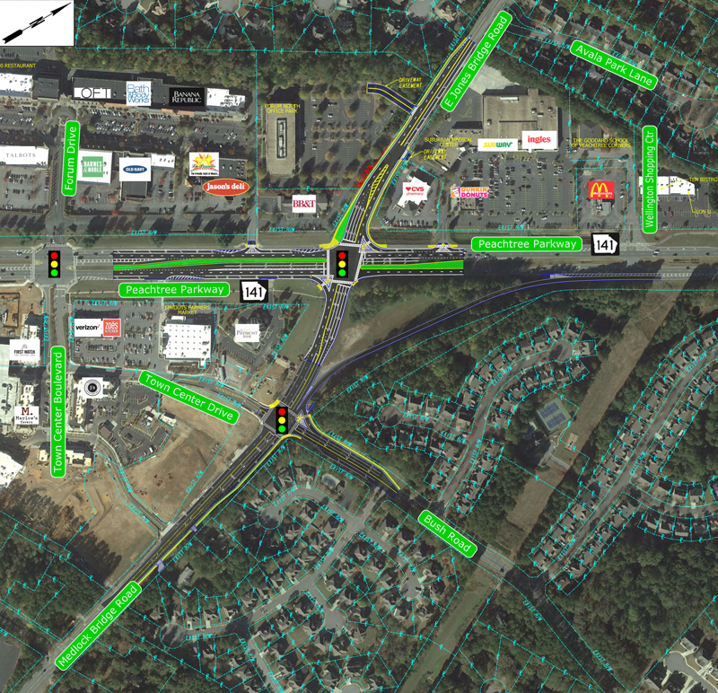

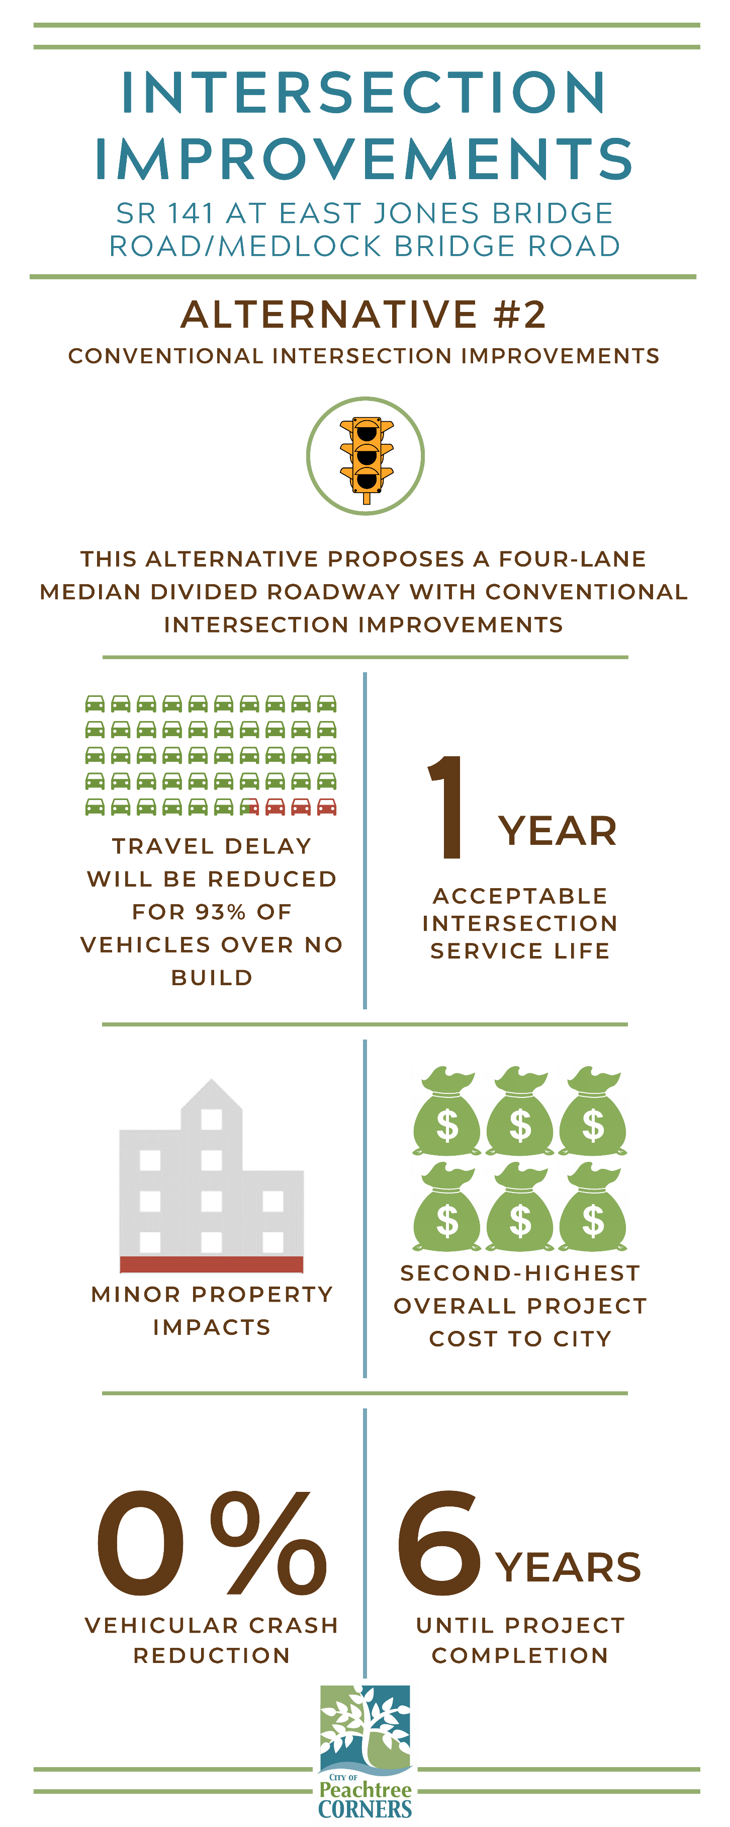
Concept Layout
SR 141 at East Jones Bridge Road/
Medlock Bridge Road
Alternative #3: Median U-Turn
September 2019

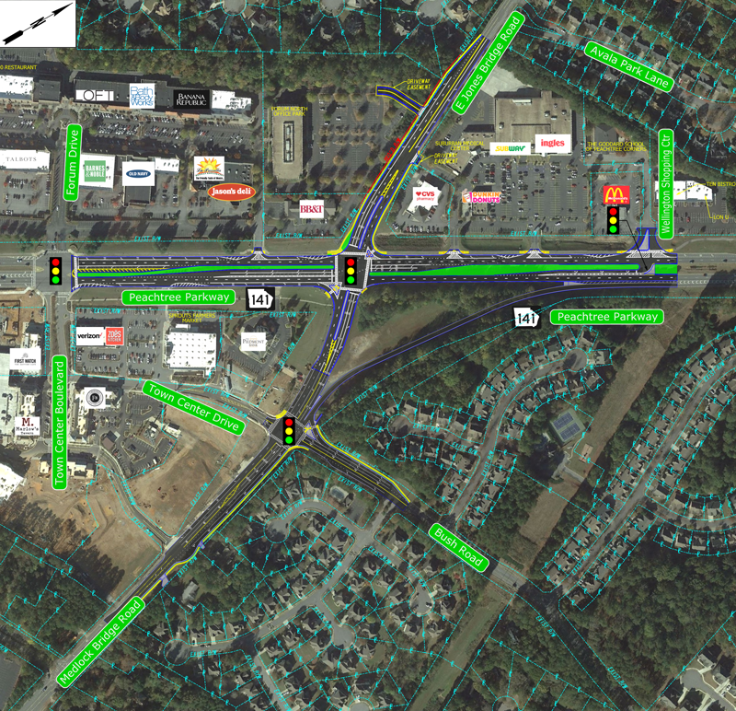

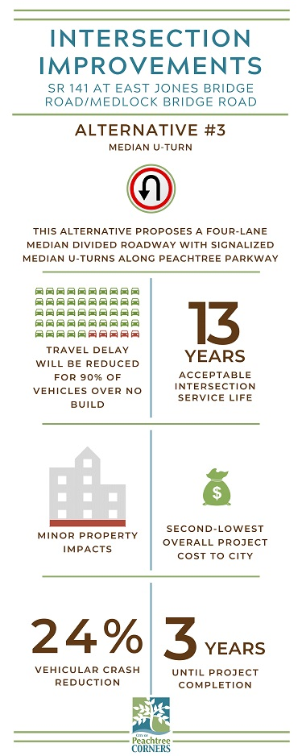
Concept Layout
SR 141 at East Jones Bridge Road/
Medlock Bridge Road
Alternative #4: Grade Separated Interchange
September 2019

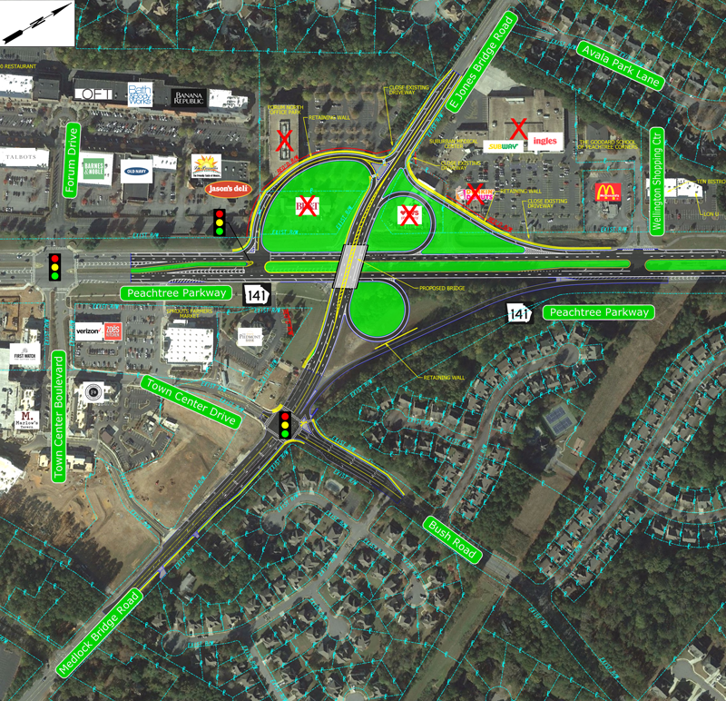

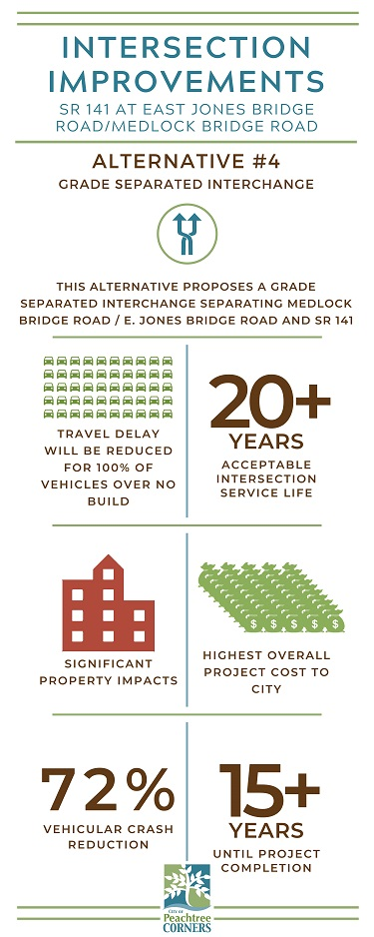
Comment Card

Please print responses.
Name
Address

General Comments

How did you hear about this Public Meeting? (check) □ Email □ City Website
□ Word of Mouth □ Social Media □ Other
Was the location of the Public Meeting convenient for you to attend? □ Yes □ No
If no, please suggest a general location that is more convenient to your community.

Was the time of the meeting convenient for you to attend? □ Yes □ No
If no, please suggest a time frame that is more convenient for you.
Were your questions answered by City personnel? □ Yes □ No
Do you understand the project after attending this meeting? □ Yes □ No
You can also provide your comments by Monday, September 30, 2019 by emailing your comments to publicworks@peachtreecornersga.gov.

