Land Use Application: CIC2024-002, CV2024-006, & CV2024-007
Planning Commission: January 21, 2025
City Council 1st Read: January 28, 2025
City Council 2nd Read: February 25, 2025
CASE NAME: CIC2024-002, CV2024-006, & CV2024-007 - 20/22 Tech Park S.

PROJECT LOCATION: 20/22 Technology Parkway S.

DISTRICT/LANDLOT: 6th District, Land Lot 272

ACREAGE: +10.7 acres

EXISTING ZONING: MUD (Mixed-Use Development District)

EXISTING LAND USE: Office building, parking deck, and associated surface parking

FUTURE LAND USE DESIGNATION: Central Business District, SAP subarea: Targeted Infill

OVERLAY(S): Activity Center Corridor Overlay District

APPLICANT: Alliance Residential, LLC
c/o Dennis J. Webb, Jr. – Smith, Gambrell, and Russell, LLP.
1105 W. Peachtree St. NE, Suite 1000
Atlanta, GA 30309

OWNER: Peachtree Community, LLC
12895 SW 132nd Street
Miami, FL 33186

PROPOSED REQUEST: Change in Conditions to allow for a mixed-use development

CONTACT: DEN WEBB
404.815.3620

STAFF RECOMMENDATION: APPROVAL with conditions of CIC2024-002
APPROVAL of CV2024-006
APPROVAL of CV2024-007
BACKGROUND:
In 2021, AHS Residential was granted a rezoning of the subject property, from M-1 (Light Industry District) to MUD (Mixed-Use Development District), pursuant to RZ2021-003, to allow for a mixed-use development. The proposal included 382 multi-family apartments, office space, and a small retail space. With this rezoning, 18 conditions were placed on the property regarding minimum indoor/outdoor retail or restaurant space square footages, minimum office space square footages, a parking area for food trucks, open space minimums, and a public art component, in the form of a large wall mural on one of the buildings.
In 2022, the subject property received a Land Disturbance Permit (LDP) from the City of Peachtree Corners. During the land development stage, AHS halted development and sold the project. Since then, Alliance Residential has submitted the current application to amend several conditions on the property in order to create a more cohesive mixed-use development.
PROJECT DATA:
The applicant, Alliance Residential, is requesting a Change in Conditions (CIC) to a large, unfinished mixed-use development, to remove and amend several conditions of zoning that currently exist on the property. The subject property is approximately 10.7 acres and was rezoned in 2021, pursuant to RZ2021-003 & V2021-004 (O2021-09-215), to allow for a development that was never constructed. The requested amendments to existing conditions of zoning specifically relate to allowing the proposed development to consist of less multi-family housing within two new buildings, as opposed to retrofitting the property to accommodate the development.
The subject property is a large parcel, located at the northeastern intersection of Technology Parkway S. and Peachtree Industrial Blvd. The site is completely developed, consisting of two full access curb cuts along Technology Parkway S., an office building, a parking deck, and associated surface parking.
A stream and its buffers bisect the site and span over a large portion of the property, running through the middle of the parcel and extending from the eastern property line, along Technology Parkway S., to the parcel’s western property line.
The applicant is proposing several amendments to the existing conditions (1, 2, 4, 11, and 17) and removing condition 12 in its entirety.
- The property shall be rezoned from M-1 to MUD and variances shall be granted to allow the development to encroach into the stream buffer up to the amount currently impacted by existing development +4,500 square feet of encroachment into the 50-foot undisturbed natural vegetative buffer and +18,500 square feet of encroachment into the 75-foot impervious setback, as shown on the site plan by Summit Engineering Consultants, Inc., dated December 19, 2024, and to reduce the one-bedroom minimum dwelling unit size from 600 square feet to 555 square feet.
- The site may be developed with up to 382 326 multi-family units. However, the maximum number of units is dependent on-site conditions, compliance with zoning conditions, and fully engineered plans that meet regulations.
- The site plan layout shall be in general conformance with the site plan submitted with this application and prepared by Bellon Architecture dated July 1, 2021 Summit Engineering Consultants, Inc., dated December 19, 2024(with revisions to meet these conditions and zoning and development regulations).
- Building elevations shall be in general conformance with the elevations submitted with this application prepared by Brock Hudgins Architects, dated November 1, 2024.
- The development shall incorporate public art in the form of a large wall mural on the side of a building visible from Technology Parkway South. The design of the mural shall be approved by Staff with assistance from the Arts Council. Completion of the mural shall occur prior to the issuance of the Certificate of Occupancy for the building on which it is installed. Total cost of the mural shall not exceed $25,000.
- All existing vegetation along Peachtree Industrial Boulevard and Technology Parkway South shall be preserved as shown on preliminary landscape plans site plan by Summit Engineering Consultants, Inc., dated December 19, 2024, submitted with this application.

If approved as proposed, the site would be developed with 326 multi-family units spread across two 5-story buildings, structured parking, 2,000 square feet of restaurant/retail space, 8,000 square feet for office space, and associated surface parking.
Aerial Map
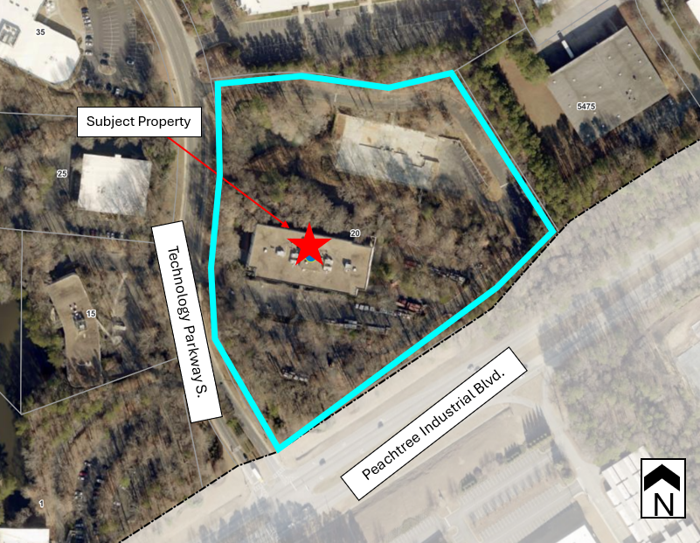
The existing conditions allow for a multifamily development of 382 housing units on the 10.7-acre site. The applicant is proposing a reduction of 56 units from the previously approved application, for a total of 326 apartment units. While also a reduction in overall density from the 2021 application of 35.7 units per acre, the proposed density for this application is 30.8, which is under the 32 units per acre maximum allowed by right within the MUD zoning district. With this reduction of units, the applicant no longer needs the density bonuses that were being proposed as a part of their previous application.
Although density bonuses are no longer needed to accommodate the proposed unit count, Alliance has discussed with staff their intention for public art and has stated they will be providing underground stormwater detention. While not required, the applicant has not referenced their intent on incorporating the previously proposed enhancements to the development (ie: parking ready for EV charging, LEED or Comparable Certification, Parking for E-scooters, Smart Technology Building Enhancements). It should be noted that while these items are not requirements for the applicant to construct the proposed development, the aforementioned amenities/upgrades would help to create an attractive and high-quality development.
ZONING HISTORY:
The subject property was rezoned in 2021 from M-1 (Light Industry District) to MUD (Mixed-Use Development District), pursuant to RZ2021-003 and V2021-004. With the approval of this rezoning, 18 conditions were placed on the property.
Zoning Map
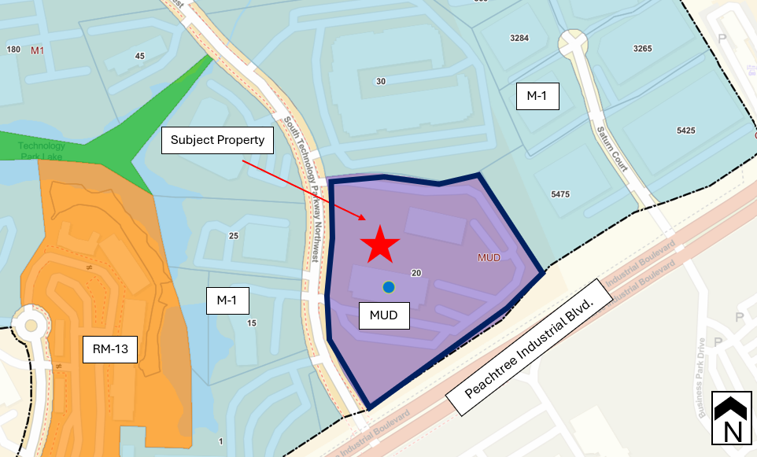
SURROUNDING LAND ANALYSIS AND ZONING
Surrounding Properties | Zoning  (Case Number) | Existing Land Use
Adjacent: North | M-1 | Vacant flex office
Adjacent: East | M-1 | Industrial buildings along Saturn Ct.
Adjacent: South | City of Norcross | Give Center West – Gwinnett County Alternative School
Adjacent: West | RM-13  (RZ2024-003) | Flex office buildings. 25 Technology Parkway S. was a recent office to condominium conversion and will contain 13 condominium units when it is complete.
COMPREHENSIVE PLAN:
Character Area Map
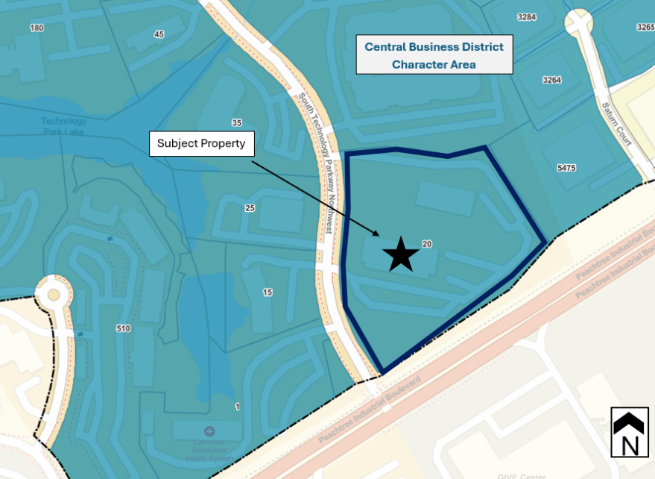
The 2045 Comprehensive Plan’s Character Area Map indicates that the subject property is located within the Central Business District (CBD) Character Area. This area encourages a wide range of mixed uses, including residential, commercial and office.
The CBD is large in area, as its boundaries span along Peachtree Parkway, from the Peachtree Parkway/Holcomb Bridge Road intersection, through Technology Park and past Town Center. Because of the land this character area covers, staff felt that doing a deeper dive into the Central Business District, analyzing each parcel, and further breaking down the character area into subareas was appropriate. The Comprehensive Plan identifies the CBD as “the most intense concentration of development and density” in the city. While this statement is appropriate in some locations within the CBD, it is not appropriate in others. As a result, the city adopted a Central Business District Small Area Plan in December of 2024, which organizes the CBD into seven subareas. The subject property is located within the Targeted Infill subarea of the CBD.
The intent for this subarea is to be strategic with adding new residential and commercial development, while preserving and enhancing existing office where possible. The Targeted Infill subarea envisions higher intensity development to be focused in areas not adjacent to existing single-family residences, with new developments being pedestrian oriented and walkable.
The subject property is on the edge of Technology Park and is a southern gateway into the City as well as Technology Park. The vision for this area is to revitalize the traditional office park into a mixed-use environment which will attract educated professionals who wish to live where they work.
CIC2024-002 – SEC. 1702 ZONING STANDARDS
CRITERIA TO BE APPLIED – CHANGE IN CONDITIONS
The criteria for change in condition decisions are provided in Section 1702 of the City of Peachtree Corners Zoning Ordinance. The specific criteria should be evaluated when considering a land use decision. The applicant is required to address these criteria (see application); below are staff’s findings which are independent of the applicant’s responses to these criteria.
A. Will this proposed rezoning, special use permit, or change in conditions permit a use that is suitable in view of the use and development of adjacent and nearby property?
The proposed change in conditions, to provide less density would allow for a less intensive development than was previously approved in 2021. The location of the proposed mixed-use development, with immediate access to Peachtree Ind. Blvd., as well as its proximity to Technology Park would be attractive to the young professional who works in the area. By providing a residential use within the southern portion of Technology Park, it is likely the daily vehicular trips would be significantly less than a multifamily development of similar size in a more suburban and less office-oriented location.
The proposed reduction in units would result in a reduction in vehicular trips as well, with approximately 24 fewer trips during the weekday A.M. peak hour, 29 fewer trips during the weekday P.M. peak hour, and 325 fewer total trips on a weekday than the property is currently entitled for.
B. Will this proposed rezoning, special use permit, or change in conditions adversely affect the existing use or usability of adjacent or nearby property?
No. The proposed change in conditions would create a less intense mixed-use development that would support the surrounding businesses in Technology Park. The proposed development would add housing stock to this area of the City and Technology Park.
C. Does the property to be affected by a proposed rezoning, special use permit, or change in conditions have reasonable economic use as currently zoned?
The property has a reasonable economic use as currently zoned.
D. Will the proposed rezoning, special use permit, or change in conditions result in a use which will or could cause an excessive or burdensome use of existing streets, transportation facilities, utilities, or schools?
Given the access points to a collector road which leads to a major roadway, it is unlikely that transportation facilities would be overburdened by the proposed development.
The project is within the attendance boundaries of Norcross Elementary School, Summerour Middle School and the student’s choice of Norcross High School or Paul Duke STEM High School. Analysis by Gwinnett County Schools indicates that the project could generate up to 61 elementary school students, 33 middle school students and 40 high school students. However, the price point for new rental apartments, the relatively small size of the units, the lack of child-friendly amenities such as playgrounds, and the marketing of the project as housing for young tech workers, single adults and childless couples means that the estimates are very likely to be higher what would actually occur. It should be noted that even if the estimates are accurate, all impacted schools have excess capacity and would be able to adequately handle the additional students.
E. Is the proposed rezoning, special use permit, or change in conditions in conformity with the policy and intent of the land use plan?
The 2045 Peachtree Corners Character Area Map indicates that the property is located in the Targeted Infill subarea of the Central Business District (CBD) Character Area. The Small Area Plan, adopted in late 2024, divided the CBD into 7 subareas, further detailing each specific subarea within the CBD.
The Targeted Infill subarea calls for higher intensity developments to be focused along major corridors and walkable, with new residential development intended to support existing nonresidential development within the CBD.
F. Are there other existing or changing conditions affecting the use and development of the property which give supporting grounds for either approval or disapproval of the proposed rezoning, special use permit, or change in conditions?
The applicant is proposing a reduction in units from the previously approved rezoning, from 382 to 326, which would result in a density of approximately 30.8 units per acre, less than the maximum allowed in the MUD zoning district (32 units per acre) and significantly lower than the site is currently entitled for (35.7 units per acre).
The City’s Comprehensive Plan envisions mixed-use development in the Central Business District. This location at the critical juncture of Peachtree Industrial Boulevard and the edge of Technology Park, near amenities such as the Corners Connector trail system, is an ideal location for this type of development. The redevelopment of this property will provide a housing type currently not offered in this area and attract people who work in Technology Park and want to live nearby.
CV2024-006 – SEC. 1315.2.5.C – ARCHITECTURAL DESIGN OF ATTACHED RESIDENTIAL BUILDINGS
The criteria for variances are provided in Section 1605 of the City of Peachtree Corners Zoning Ordinance. The specific criteria should be evaluated when considering a variance. Such variances are evaluated on a case-by-case basis and may be granted in cases of unnecessary hardship.
Code Section 1315.2.5.C requires that “architectural treatments of each building elevation (of all attached residential buildings) shall be a minimum 50% brick, stone, or stucco. The balance of each building elevation may be wood, wood shake, or fiber cement-type siding.” This requirement is intended to ensure that development within the Activity Center Corridor Overlay maintains a unified aesthetic and enhances the viability of the area surrounding major activity centers within the city.
CRITERIA TO BE APPLIED (CONCURRENT VARIANCE)

A. There are extraordinary and exceptional conditions pertaining to the particular property in question because of its size, shape or topography.
The subject property is unique in that the site has significant topography and drops off from Peachtree Industrial Blvd. With that, new development would essentially sit in a hole and will be less visible than that of a development at grade with the road. This, paired with the heavily wooded nature of the periphery of the property also serves as a visual buffer obscuring the development from adjacent roadways. Further, the proposed variance is to reduce the minimum requirement of brick, stone, and/or stucco, for building elevations interior to the development, by 8%, to allow for 42% brick, stone, and/or stucco, on each elevation rather than 50%. The submitted renderings show all building elevations visible from the right-of-way as having more than 50% brick, stone, and/or stucco.
B. The application of the Resolution to this particular piece of property would create an unnecessary hardship.
Surrounding buildings within Technology Park are more modern than other locations within the city. Within the Activity Center Corridor Overlay, nonresidential buildings may be designed with glass and/or brick, stone, or stucco. While the project contains a large residential element, the overall development is mixed-use in nature and includes an office and a retail/restaurant component. The intent of the architectural requirement for attached residential products to have a minimum of 50% brick, stone, and/or stucco is in keeping with the more suburban portions of the Activity Center Corridor Overlay. This project; however, may look out of character in Technology Park if developed with the required architectural treatments of a typical attached residential development.
C. Such conditions are peculiar to the particular piece of property involved.
Although the subject property is located within the Activity Center Corridor Overlay District, the site is on the periphery of the overlay and is more particularly associated with Technology Park, specifically as a southern gateway into the area. The Activity Center Corridor Overlay requires that architectural treatments of each building elevation (of all attached residential buildings) shall be a minimum 50% brick, stone, or stucco. The intent of this requirement is for attached residential developments in more suburban areas of the city.
The applicant is proposing architecture more in keeping with the character of Technology Park, with a significant portion of glass as one of the primary materials for each building elevation. In proposing glass, the applicant is furthering the city’s goals of creating a cohesive look and feel throughout Technology Park. It should be noted that the City’s architectural regulations for the MUD zoning district state “for multifamily residential buildings: architectural treatments of each building elevation shall be a minimum 50% brick, stone, glass, and/or stucco.” Further, the nonresidential and commercial/retail buildings within the Activity Center Corridor Overlay allow architectural treatments consisting of glass and/or brick, stone, or stucco.
D. Such conditions are not the result of any actions of the property owner.
The applicant has a unique challenge as the Activity Center Corridor Overlay divides uses into three categories when discussing architectural design. Being primarily a multifamily development, the project most closely aligns with the designation of an attached residential building. If this parcel were located on a property not within the Activity Center Corridor Overlay, relief would not be necessary as glass is a permitted primary material within the MUD zoning district.
E. Relief, if granted, would not cause substantial detriment to the public good nor impair the purposes or intent of this Resolution.
It is not anticipated that the proposed development would cause substantial detriment to the public good. Allowing for a reduction in required materials would create a more modern look to the development that would fit with the sleek character of existing office stock within Technology Park.
The applicant’s proposal, for a reduction in the required brick/stone materials by 8%, is only intended for the facades internal to the development, as these facades will include recessed balconies. Facades that face public right-of-way exceed the 50% minimum brick, stone, and/or stucco requirement.
It should be noted that this requirement for brick, stone, or stucco is specific to the Activity Center Corridor Overlay. Within this overlay, uses are divided into three categories with regards to architectural design; non-residential, commercial/retail, and attached residential.
Sec. 1318.13 of the City’s Zoning Ordinance; however, states “for multifamily residential buildings: architectural treatments of each building elevation shall be a minimum 50% brick, stone, glass, and/or stucco.” Glass is a durable material that improves energy efficiency, brings natural light into a building, and contributes to overall sustainability. Additionally, glass provides a sense of transparency and openness to a development, without sacrificing the component of privacy.
Although the MUD zoning district allows for glass as a primary architectural treatment, the regulations of the overlay supersede those of the MUD zoning district.
In keeping with the character of Technology Park, the applicant is proposing a large portion of the development’s facades be glass; however, in doing so, their proposed brick and stone percentages are slightly under the 50% minimum, making it necessary that a variance be requested.
F. Is the proposed rezoning, special use permit, or change in conditions in conformity with the policy and intent of the land use plan?
The requested variance is consistent with the spirit and purpose of this chapter and the Comprehensive Land Use Plan. If approved, this variance would help to create a development that fits with the character of Technology Park and will enhance the aesthetics of the southern gateway into Technology Park. The redevelopment of this property will provide a mixed-use development that will attract people who work in Technology Park and want to live nearby.
Staff recommends APPROVAL of CV2024-006.
CV2024-007 – CHAPTER 18, ARTICLE III - STREAM BUFFER PROTECTION
The criteria for variances are provided in Section 1605 of the City of Peachtree Corners Zoning Ordinance. The specific criteria should be evaluated when considering a variance. Such variances are evaluated on a case-by-case basis and may be granted in cases of unnecessary hardship.
The applicant is requesting approximately 23,000 square feet of encroachment and/or impact to the city’s 50-foot undisturbed buffer and 75-foot no impervious surface setback, a reduction of 17,000 square feet than what currently exists on the property and was entitled for.
CRITERIA TO BE APPLIED (CONCURRENT VARIANCE)

A. There are extraordinary and exceptional conditions pertaining to the particular property in question because of its size, shape or topography.
The property and proposed project have extraordinary and exceptional conditions as a large pond, stream, and buffers bisect the site, creating a largely unusable portion of the property. Further, the subject property is entitled for a mixed-use development with encroachments into the city’s 75-foot no impervious surface setback and 50-foot undisturbed buffer, as well as the state 25-foot undisturbed buffer totaling approximately 40,000 square feet. While the previous applicant intended on reusing one of the office buildings, the 2021 rezoning maintained the 40,000 square feet of impact to the stream’s buffers and no impervious surface setback.
The applicant intends on removing approximately 8,831 square feet of impervious surface from the 75-foot no impervious surface setback, 7,974 square feet of impervious surface from the 50-foot undisturbed buffer, and 829-square feet of impervious surface from the state 25-foot undisturbed buffer, resulting in the restoration of the setback and buffers of approximately 33%, 66%, and 87%, respectively.
The proposed site plan shows approximately 4,052 square feet of encroachment into the 50-foot undisturbed buffer and 17,615 square feet of encroachment into the 75-foot no impervious surface setback, for a total of approximately 21,667 square feet of impervious surface. The submitted site plan does not show any new impervious surface within the 25-foot state undisturbed buffer.
B. The application of the Resolution to this particular piece of property would create an unnecessary hardship.
The literal interpretation and strict application of the applicable provisions or requirements of this chapter could cause undue and unnecessary hardship as the site is inundated by a pond, stream, its buffers, and significant topography.
Additionally, the previously approved plan proposed approximately 40,000 square feet of impact into the 25-foot state undisturbed buffer as well as the 50-foot city undisturbed buffer and the city 75-foot no impervious surface setback. While the previous applicant intended on using an existing building, the proposed intrusion into the stream buffers and setback were notably greater than that of the current request.
C. Such conditions are peculiar to the particular piece of property involved.
The subject property is unique in that the infrastructure and surface parking already exist. The site is also bisected by an existing pond, stream and its buffers, making a large portion of the property unusable. That, paired with the steep topography make the proposed project even more challenging. By allowing an encroachment into the city’s 50-foot undisturbed buffer and 75-foot no impervious surface setback, the site is awarded some relief for the challenges the existing geographical features present that many other sites do not encounter.
D. Such conditions are not the result of any actions of the property owner.
A large stream, pond, and buffers inundate a considerable portion of the property. As a result, the site is significantly impacted by topography. The applicant is proposing to mitigate the existing stream encroachment and is proposing less of an intrusion than currently exists on the property.
E. Relief, if granted, would not cause substantial detriment to the public good nor impair the purposes or intent of this Resolution.
The proposed stream buffer encroachment will result in a development that has less impervious surface than exists on the site currently. It should also be noted that the proposed development would result in less impervious surface than the previous application was entitled for.
The applicant intends to develop within the footprint of the existing buildings (built prior to the incorporation of the city and requirement for stream buffers) and approved buildings (not constructed but entitled with the previous application).
F. Is the proposed rezoning, special use permit, or change in conditions in conformity with the policy and intent of the land use plan?
The requested variance is consistent with the spirit and purpose of this chapter and the Comprehensive Land Use Plan’s Community Work Program to maintain a high-quality natural environment.
Staff recommends APPROVAL of CV2024-007.
DEPARTMENT ANALYSIS:
The subject property is a 10.7-acre parcel located on the eastern side of Technology Parkway South at its intersection with Peachtree Industrial Boulevard. The applicant is proposing a change in conditions to amend several existing conditions of zoning (1, 2, 4, 11, and 17) and the removal of a condition (12) in its entirety. The applicant is proposing to develop the site with 326 multi-family units spread across two 5-story buildings, structured and surface parking, 2,000 square feet of restaurant/retail space, and 8,000 square feet for office.
The 2045 Comprehensive Plan shows the property located in the Targeted Infill subarea of the Central Business District, indicating that the location is desirable for mixed-use development and density complimentary and accessory to surrounding office and commercial uses. The property is also close to the city’s Corners Connector trail system which intersects Technology Parkway South approximately 650 feet from the edge of this property. A sidewalk connection already exists between the site and the trail.
The applicant submitted architectural elevations as part of the rezoning request which show a modern design, with flat rooflines, a mixture of exterior materials consisting of brick, fiber cement siding, board and batten, and glass, in a variety of earth-tone colors. The proposed structures will blend seamlessly with the surrounding buildings in Technology Park. The applicant has requested a variance to allow for a reduction in the required architectural treatments of each building elevation for attached residential buildings within the Activity Center Corridor Overlay (CV2024-006). The requested variance would result in a reduction of the minimum brick, stone, and or/stucco percentage by 8%, from 50% to 42%. It should be noted that the facades that front public right-of-way exceed the 50% requirement of brick, stone, and/or stucco. The requested variance is to allow the facades internal to the development to be developed with 42% brick, stone, and/or stucco, with the remaining materials being a mixture of glass, board and batten, and fiber cement siding.
The Activity Center Corridor Overlay divides uses into three categories with regards to architectural design, non-residential, commercial/retail, and attached residential and does not consider glass to be an appropriate primary material; however, the architectural requirements for multifamily residential buildings within the MUD zoning district conflict with the overlay and do consider glass as an appropriate primary material. It should be noted that the amount of glass proposed for each elevation would significantly exceed the minimum 50% material requirement if glass were an allowed primary material for this type of development (The Activity Corridor Overlay considers this use as attached residential).
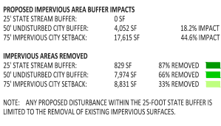
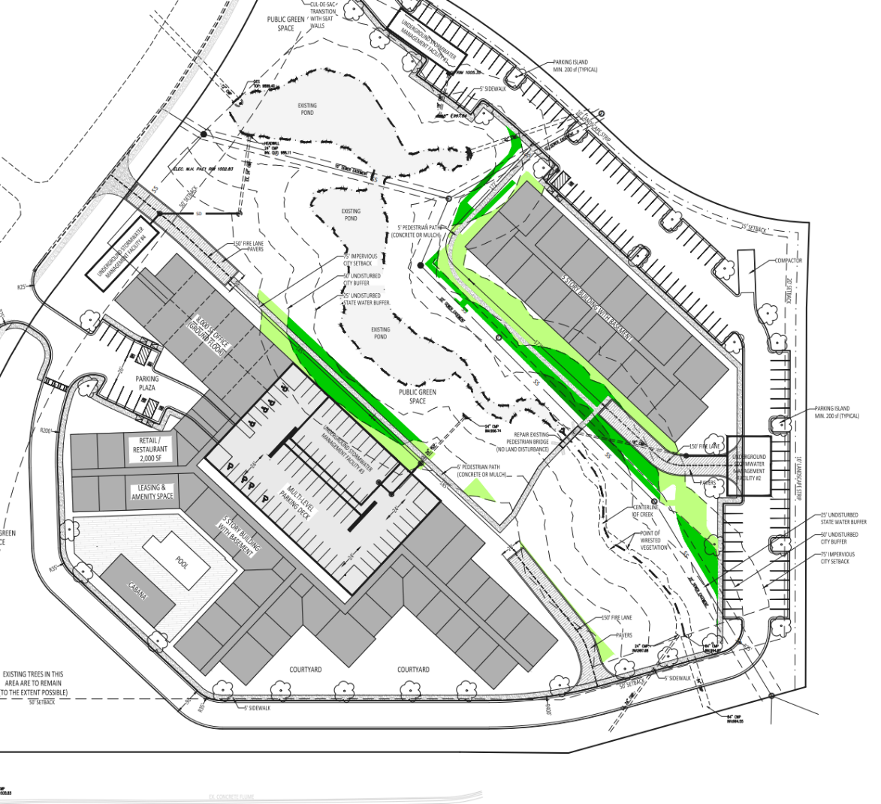
The submitted site plan shows approximately 4,052 square feet of encroachment into the city’s 50-foot undisturbed buffer and 17,615 square feet of encroachment into the 75-foot no impervious surface setback, for a total of approximately 21,667 square feet of impervious surface, a significant reduction in impervious surface to what currently exists on the site and what the property is entitled. Although the previous applicant intended to reuse an office building to offset the amount of intrusion the development would create, Alliance is proposing two new buildings, within a smaller footprint than currently developed, which will result in a reduction of approximately 17,634 square feet of impervious surface to the property.

CONCLUSION:
The proposed change in conditions would result in a less intense development than currently exists and is entitled for at this southern gateway into the city and Technology Park. The applicant’s proposal, to reduce the number of multifamily units within the development, from 382 to 326 and to develop the property in a way that the proposed buildings intrude less into the city’s 50-foot undisturbed buffer and 75-foot no impervious surface setback further the city’s goals of protecting its’ streams and buffers.
Therefore, Staff recommends APPROVAL WITH CONDITIONS of the requested change in conditions.
STAFF RECOMMENDATION
Based on the findings and conclusions herein, Staff recommends APPROVAL of Land Use Petition CIC2024-002, CV2024-006, and CV2024-007, subject to the following conditions: (additions = bold; deletions = strikethrough).
- The property shall be rezoned from M-1 to MUD and variances shall be granted to allow the development to encroach into the stream buffer up to the amount currently impacted by existing development +4,500 square feet within the 50-foot undisturbed buffer and +18,500 square feet within the 75-foot no impervious surface setback, as shown on the site plan by Summit Engineering Consultants, Inc., dated December 19, 2024, (CV2024-007) and to reduce the one-bedroom minimum dwelling unit size from 600 square feet to 555 square feet.
- The site may be developed with up to 382 326 multi-family units. However, the maximum number of units is dependent on-site conditions, compliance with zoning conditions, and fully engineered plans that meet regulations.
- The site shall contain a minimum of 2,000 square feet of indoor/outdoor retail or restaurant space, 8,000 square feet of office space and a food truck parking area as shown on the submitted plan.
- The site plan layout shall be in general substantial conformance with the site plan submitted with this application and prepared by Bellon Architecture dated July 1, 2021 Summit Engineering Consultants, Inc., dated December 19, 2024 (with revisions to meet these conditions and zoning and development regulations).
- The 2.6 acres of open space being dedicated for public use for a density bonus shall be subject to an easement which ensures its open access to the public.
- Development shall include no more than the two access points as shown on the submitted site plan.
- All stormwater detention shall be underground and all on-site facilities shall be constructed to meet the standards of the City of Peachtree Corners Stormwater Ordinances including, but not limited to, stormwater detention, water quality standards, stream protection and management of off-site drainage flowing through the site.
- All stormwater facilities shall be owned and maintained by the owner of the subject property in accordance with the City of Peachtree Corners Stormwater Ordinances.
- The developer shall provide sidewalk connectivity between all buildings within the site and provide pedestrian sidewalk connections from the development onto the public sidewalk network along Technology Parkway South.
- The developer shall provide a central mailbox for the community with adequate pedestrian access.
- Building elevations shall be in general substantial conformance with the elevations submitted with this application prepared by Brock Hudgins Architects, dated November 1, 2024. Building facades shall be developed with a minimum of 42% brick/stone, except facades facing public right of way shall have a minimum of 50% brick/stone, subject to review and approval by the Community Development Director. (CV2024-006).
- The development shall incorporate public art at a cost not to exceed $25,000.in the form of a large wall mural on the side of a building visible from Technology Parkway South. The type of art and final design of the mural shall be reviewed and approved by Staff with assistance from the Arts Council. Completion of the mural public art shall occur prior to the issuance of the Certificate of Occupancy for the last building. for the building on which it is installed. Total cost of the mural shall not exceed $25,000.
- Bicycle racks shall be provided within the development in accordance with the overlay standards.
- The multi-family site shall incorporate an outdoor grilling and seating area with fireplace or fire pit.
- The multi-family building shall have controlled access at all pedestrian entry points.
- With regard to the multi-family units, the following shall apply:
  - Each unit shall have General Electric stainless-steel kitchen appliances (or equal).
  - All kitchens shall include granite countertops (or equal material such as quartz).
  - Designer ceramic tile backsplashes shall be provided in all units.
  - Floor finish materials shall be tile, carpet, luxury vinyl tile/plank, or engineered wood. Concrete flooring shall be prohibited.
  - For increased privacy and reduced sound transmission, each unit shall have a minimum 7/16" 6-lb pad under all carpeted areas.
  - All units to be equipped with light fixtures, either recessed can light and/or ceiling mount fixtures and/or wall sconces.
  - All bathrooms shall have granite countertops (or equal material such as quartz).
  - All bathrooms shall have tiled shower/tub surrounds.
  - All units shall have nine-foot ceilings throughout.
  - All bedrooms shall include a walk-in closet, except for the one bedroom with den which shall include a full room-length wall closet.
  - All units shall be equipped with a full-size washer and dryer.
  - Pre-wiring for security systems shall be provided in all units.
  - All units shall be equipped with an automatic fire sprinkler system.
  - Walk-out balconies shall be a minimum depth of 4'-0", including the portion of the balcony that is recessed into the building for privacy reasons. Juliet balconies, which provide no privacy, shall be prohibited.
  - The property owner shall provide elevators and elevator lobbies.
  - All interior corridors shall be enclosed and climate controlled. Open air breezeways shall be prohibited.
  - The property owner shall provide a resort-style swimming pool and courtyard.
  - Children's playground equipment shall be prohibited on the property.
  - The property owner shall provide trash chutes internal to the building so residents do not have to carry their trash downstairs.
  - All interior corridor floor finish materials shall be tile, carpet, luxury vinyl tile/plank, or engineered wood. Concrete flooring shall be prohibited.
- All existing vegetation along Peachtree Industrial Boulevard and Technology Parkway South shall be preserved as shown on preliminary landscape plans submitted with this application and landscape plans, that comply with the city’s regulations shall be required.
- This property shall participate in the crime-free multi-family housing program.

